Writing for Mrs. Geiger’s students – March 23 – March 27
Do this each day Monday through Friday
Kinds of Weather
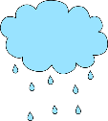
Sunny Rainy Cloudy
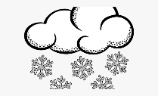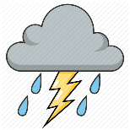
Windy Snowy Stormy
I am a weather reporter!
Go outside with mom or dad.
Ask: What is the weather today?
Draw a picture to show the weather.
Tell someone about your drawing.
Label your drawing.
Write a sentence about the weather. You can use this sentence starter if you need to…..
“The weather is __________.”
Tell someone how the weather is the same or different as yesterday.
Tell someone what you think the weather will be tomorrow.

